**Australian Social Realism**

Through the economic depression and World War Two, progressive artists were closely aligned with the international anti-Fascist cause. Social realist artists such as Noel Counihan (1913-86), Vic and Ailsa O’Connor (1918-2010; 1921-80), Jacqueline Hick (1919-2004), Nan Hortin (1916-71) and Roy Dalgarno (1910-2001) drew upon realist and expressionist tendencies in European and US modernism to depict universalised expressions of human suffering and hope. They felt this influence most directly through the expressionist canvases of European émigrés like Josl Bergner (b.1920), Danila Vassilieff (1897-1958) and Sali Herman (1898-1993). Many artists in the Social Realist group were active in the left-leaning Melbourne Contemporary Art Society, where they engaged in heated debates on the social role of modern art. The Social Realists saw themselves as creative witnesses to current events, employing accessible, figurative and often narrative forms to depict the Australian character, the nature of work, poverty and labour relations, freedom of speech, anti-Semitism and wartime experiences. Expressive realism was the most economical and creative way to connect directly with audience emotions, in order to persuade people to change their minds and to take action.

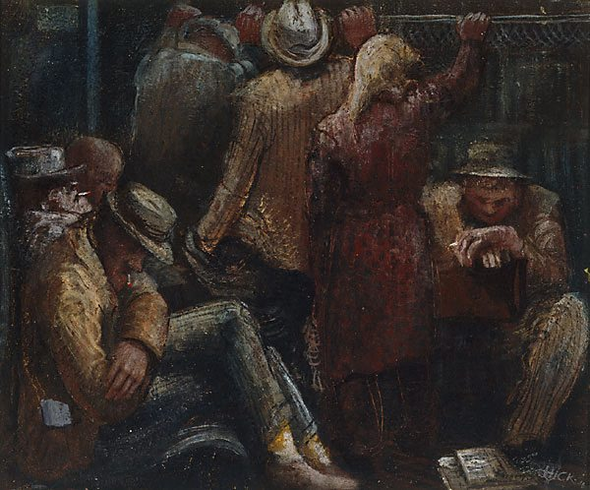

Jacqueline Hick, *Late shift workers* (1945), oil on canvas 51.0 x 61.0 cm stretcher; 66.6 x 76.7 x 5.0 cm frame, AGNSW (http://www.artgallery.nsw.gov.au/collection/works/7826/)

Through rendering ‘typical’ characters and everyday scenes, Social Realist artists could express and recuperate the fragmented and alienated nature of life under capitalism. They created new and challenging perspectives by painting from the point of view of workers and other marginal groups such as women, migrants and aborigines. The challenge was to depict recognisable social scenarios and social types that were also richly individualised, as in Hick’s *Late Shift Workers* (1945). In similar vein, Counihan’s abstracted memory of a family at an unemployed workers’ demonstration during the depression, *At the Start of the March, 1932* (1942), connects two dark periods in history (the Depression and WWII) through the unifying figure of a stoic Australian family who pull together in troubled times. Like many Social Realist figures, they are simultaneously an individual family group and yet represent a collective Australian spirit and generalisable humanist values.

**References and further reading:**

For further bibliographical details of individual artists see also *The Dictionary of Australian Artists Online*, at [www.daao.org.au](http://www.daao.org.au)

Haese, R. (1981) *Rebels and Precursors: The Revolutionary Years of Australian Art*, Melbourne: Allen Lane (A useful social history of the major tendencies in progressive Australian art of the period).

*Angry Penguins and Realist Painting in Melbourne in the 1940s: Hayward Gallery, London, 19 May to 14 August 1988*, South Bank, London, 1988 (This exhibition catalogue represents the intertwined tendencies in progressive art and debate in wartime Melbourne).

Merewether, C. (1984) *Art & Social Commitment: An End to the City of Dreams 1931-1948*, Sydney: Art Gallery of New South Wales (This scholarly exhibition catalogue outlines the similarities and divergences of the social realists and *Angry Penguins* groups).

O’Connor, A. (1982. Section on ‘Why Realism?’ in *Unfinished Work: Articles and Notes on Women and the Politics of Art*, Melbourne: Greenhouse Publications (This is a thoughtful and partisan account of the history and ideas of social realism, by one of the Melbourne group’s younger members).